Chapter 1 Mini Quiz
Cross out the word in each group that is NOT a preposition.
1. next to, above, table
2. in, weather, on
3. women, between, next to
3. in front of, in back of, box

Cross out the word in each group that is NOT a noun.
1. game, student, smart
2. they, house, window
3. desk, person, we
4. couch, class, above

Cross out the word that is NOT a pronoun.
1. employee, I, we
2. They, you, girl
3. he, she, store
4. they, beautiful, we

Cross out the word that is NOT an adjective.
1. ugly, smart, she
2. gold, house, lazy
3. they, pretty, smart
4. dirty, between, hardworking

Cross out the incorrect sentence.
1. The desk is next the chair. The desk is next to the chair.
2. I am at class. I am at the class.
3. She is in Main Street. She is on Main Street.
4. The cat is between the car. The cat is between the cars.

Write the preposition of each drawing.
4. ___________
2. ___________
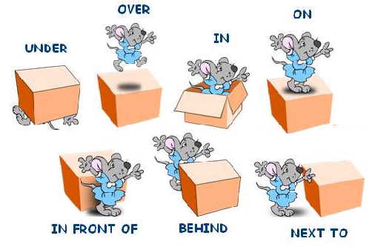
7. ___________
6. ___________
5. ___________________
3. ___________
1. ___________
Write the sentence that corresponds to each drawing.
1. ex. The mouse is ___________________ the box.
2.
3.
4.
5.
6.
7.
Complete each sentence with at, in, on, or between.
1. I am _____ Moab.
2. She is ______ the boat.
3. They are ________ City Market.
4. Sam is _______ Main Street.
5. Sandy is ________ 125 W 200 S.
6. My daughter is _____ school.
7. The path is _______ the houses.

Translate the following sentences.
1. Los gatos están en la casa. ____________________________________________________
2. Gale está en la cocina. __________________________________________________
3. Las sillas están al lado del escritorio. ___________________________________________________
4. Ella está detrás de su hermano. ______________________________________________________

Read the paragraph and answer the questions. Use complete sentences. Do not use contractions.
Elizabeth is bored. She is at her house, but her house is empty. Her sister is at school. Her mother and father are at work. Her brother is on vacation. Her cat is hiding under the table. Her dog is outside in his doghouse. Her friends are at their houses. Her friend, Sally, is busy with homework. Her other friend, Bob, is sick. He is sleeping in bed. Elizabeth goes to her bookshelf. She chooses a book and reads. Elizabeth is not bored anymore.
1. Where is Elizabeth?
2. Where is her sister?
3. Where are her parents?
4. Where is her bother?
5. Where is her cat?
6. Where is her dog?
6. Where are her friends?
7. Where is Sally?
8. Where is Bob?
Look at Fred's schedule. Then, answer the questions. Use complete sentences. Do not use contractions.
Time | Location
6:00 am | Home
7:00 am | South Town Gym
8:00 | School
9:00 | English Class
10:00 | Work
11:00 | Work
12:00 (noon) | Lunch
1:00 pm | Work
2:00 PM | Work
3:00 | School
4:00 | Math class
5:00 | Library
6:00 | City Market
7:00 | Home

Where is Fred at 6:00 am?
Where is Fred at 7:00 am?
Where is he at 8:00 am?
Where is he at 11:00 am?
Where is Fred at 12:00 (noon)?
Where is he at 4:00 pm?
Where is he at 5:00 pm?
Where is he at 6:00 pm?

Make an imaginary schedule of your day.
Time | Location
6:00 am
7:00 am
8:00
9:00
10:00
11:00
12:00 (noon)
1:00 pm
2:00 PM
3:00
4:00
5:00
6:00
7:00

Write 3 sentences about your schedule.
Ex. At 8:00 in the morning, I am at my house.

