Chapter 3 Mini Quiz
Complete the sentence with There is or There are.
_______________ a class in the university.
_______________ a car in the parking lot.
_______________ many people at City Market.
_______________ five students in the class.
_______________ a park near my house.
_______________ a hole in my sock.

Complete each sentence with there or they're.
___________ at my house.
___________ are coins in your pocket.
___________ are many pages in the book.
___________ in my purse.
___________ is a national park nearby.
___________ is a pencil in my hand.

Complete each sentence with There or They.
_________________ are at school.
_________________ are many tourists in Moab.
_________________ are my classmates.
_________________ are teachers in the school.
_________________ are 21 years old.
_________________ are trees outside.

In the first column, write Q if the sentence is a question and S if the sentence is a statement. In the second column, write a period (.) or a question mark (?).
Is there a doctor in the room __________________ ______________
Is there a English class is Moab __________________ ______________
There are four coffee shops __________________ ______________
Is your house nearby __________________ ______________
Is there a student from Thailand __________________ ______________
Is your sister in Utah __________________ ______________
Is there a water bottle in your car __________________ ______________

Read the paragraph and respond to the questions. Use complete sentences. When you can, use contractions.
Mark is happy. He is home from his university in Salt Lake City. He is not bored because there is a lot to do in Moab. There isn't a beach, but there is the Colorado River. It is hot outside. Mark wants a drink. There isn't lemonade in the fridge. He is also hungry. Mark's phone rings. It's his friend, Annabelle. She invites Mark to have a picnic near the river. They meet at City Market and go to have fun!
Is Mark bored? ______________________________________________________
Is there a river near Moab? ____________________________________________
Is there lemonade in the refrigerator? ___________________________________
Is Mark Annabelle's friend? ____________________________________________
Is Mark hungry? _____________________________________________________
Is Mark sad? ______________________________________________________

One of the sentences in each line is not correct. Cross out the incorrect sentence.
There is flour in the jar. There is a flour in the jar.
There is cheese on the cracker. There is a cheese on the cracker.
There is many children in the park. There are many children in the park.
There are meat on the plate. There is meat on the plate.
There is a books on the table. There is a book on the table.
There is a doctor in our class. There is an doctor in our class.
There are three pencils in my bag. There is three pencils in my bag.

Translate the following sentences. When you can, use contractions.
Hay un libro en mi mochila. ___________________________________________
Hay una profesora en la clase. __________________________________________
Hay manzanas en la silla. ___________________________________________
Hay dos estudiantes en mi clase. ________________________________________
Hay cuatro sillas en la aula. ___________________________________________
Hay café en la taza. ___________________________________________
Hay gatos en la casa. ___________________________________________
Write count or noncount next to each noun.
Class ___________________________________________
Rice ___________________________________________
Jelly ___________________________________________
Milk ___________________________________________
Grape ___________________________________________
Money ___________________________________________
Can you think of any other noncount nouns? ______________________________

Look at the following picture. First, respond to each question with a long answer. When you can, use contractions. Then, use of the following short answers:
Yes, there is. No, there isn't. Yes, there are. No, there aren't.
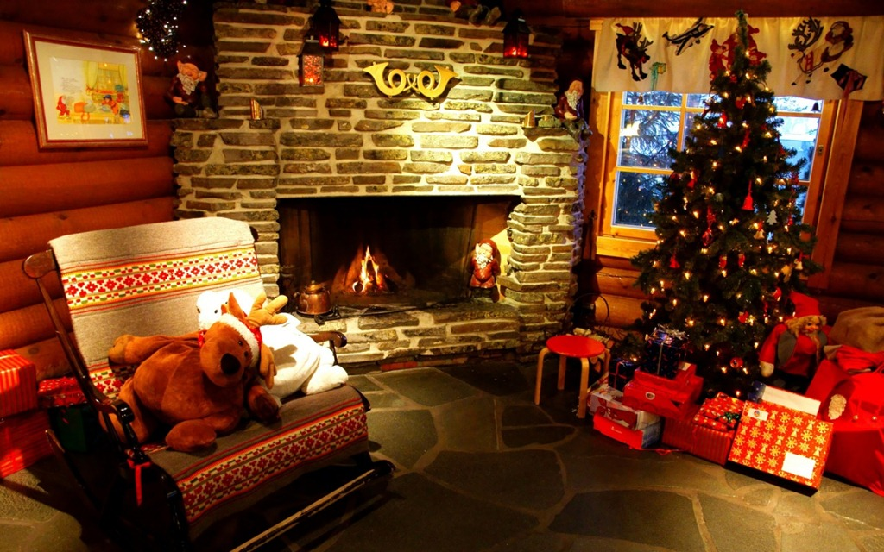
Is there a tree in the room? ___________________________________________
_____________________________________________________________
Are there gifts on the floor? ___________________________________________
_____________________________________________________________
Is there a blanket on the floor? ________________________________________
_____________________________________________________________
Are there lights on the tree? ___________________________________________
_____________________________________________________________
Is there a star on top of the tree? _______________________________________
_____________________________________________________________
Is there a fire in the fireplace? _________________________________________
_____________________________________________________________
Are there family photos on the wall? ____________________________________
_____________________________________________________________

