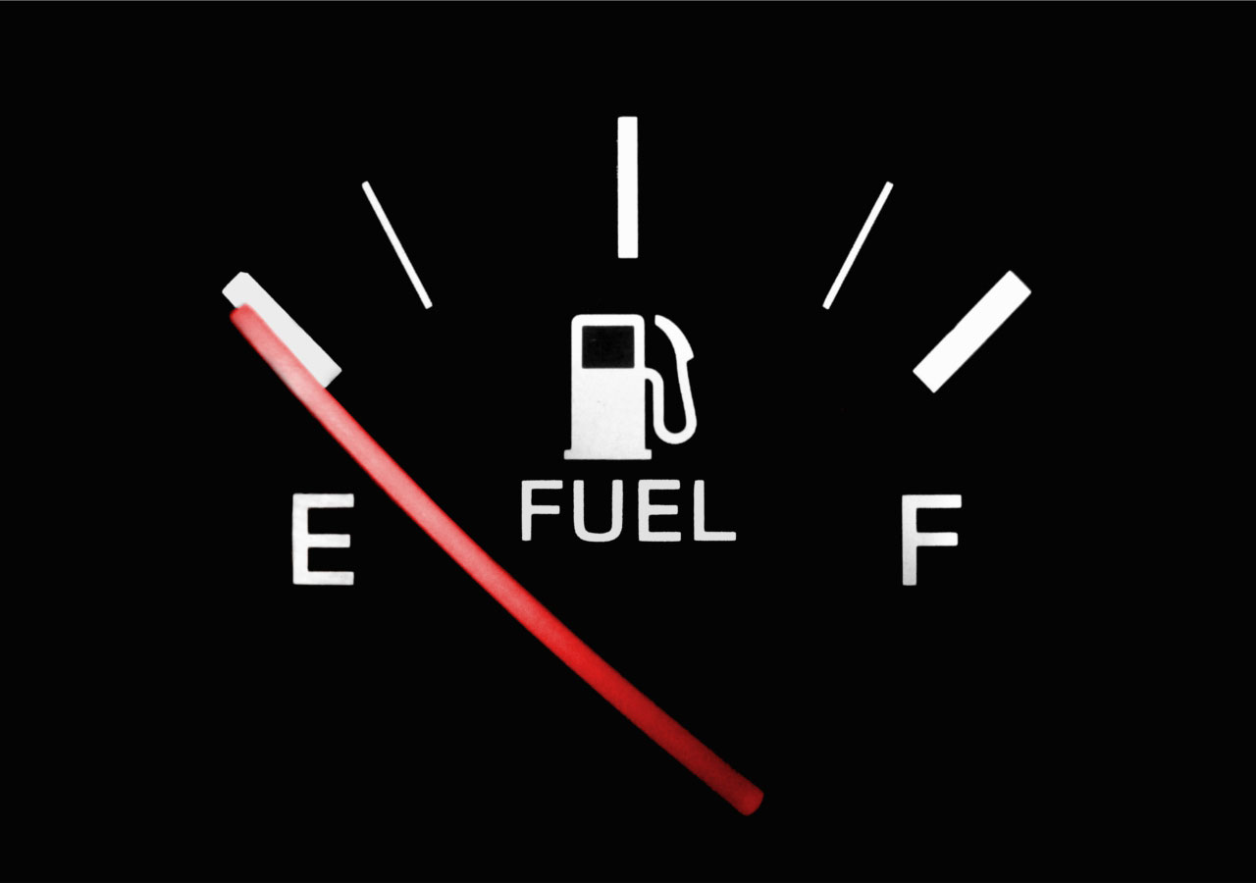
There _______ gasoline in the car.

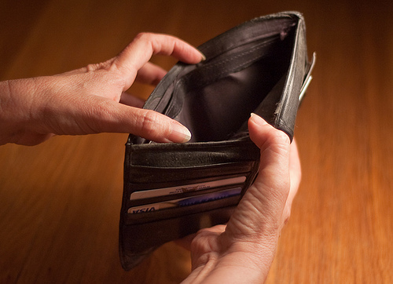
There _______ money in the wallet.
There _________ dollar bills in the wallet.

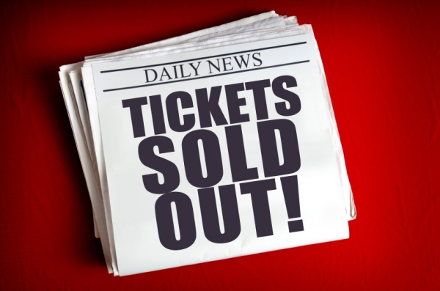
There ______ tickets available.
There ______ an empty seat.
There _______ empty seats.
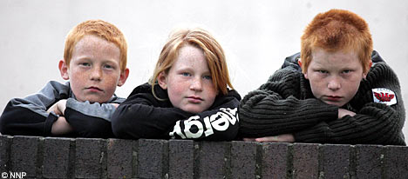
They _______ happy.
She _______ old.
They _______ blondes.
He ______ smiling.

